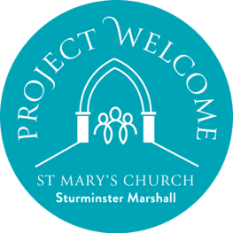

St Mary's church, Sturminster Marshall: Project Welcome

Outreach Co-ordinator vacancy

Closing date for applications: Saturday 14 March 2026

Please download and fill in this application form and email it with your CV to: wendy.bailey@hotmail.com

Section 1: Personal Details

Full Name:

Address:

Postcode:

Phone Number/s:

Email Address:

Date of Birth:
_______________________________________________________________________________

Section 2: Background and Experience

Current Occupation / Role:

Please provide a summary of your professional and voluntary experience relevant to this application to become the Outreach Co-ordinator for St Mary's church, Sturminster Marshall

Do you have previous experience as a co-ordinator or manager of a small venue
☐ Yes ☐ No
If yes, please provide brief details:

______________________________________________________________________________

Section 3: Skills and Interests
Which of the following skills/areas can you contribute to St Mary's church
☐ venue management
☐ communications and marketing
☐ community engagement
☐ finance / accounting
☐ Other (please specify):
What interests you about becoming the Outreach Co-ordinator at St Mary's church?

What do you believe you could bring to the role?

_________________________________________________________________________

Section 4: Availability and Commitment
Are you able to start work in April 2026 as a Volunteer, and as a self-employed contractor from 1 June 2026?
☐ Yes ☐ No ☐ Maybe
Are you able to commit to approximately 10-15 hours a week to the role?
☐ Yes ☐ No ☐ Maybe
_______________________________________________________________________________

Section 5: References
Please provide details of two people who can provide a reference:
Referee 1 Name: Referee 2 Name:

Relationship: Relationship:
Email/Phone: Email/Phone:
______________________________________________________________________________
Signature:
Date:

